GUIDE TO INFELLOWSHIP

TABLE OF CONTENTS

Why InFellowship……………………………………………………………………………….3
Create Your Account…………………………………………………………………………...4
How to Access Your Group…………………………………………………………………....5
Group Features // Dashboard….……………………………………………………………..5
Group Features // Roster……….………………………………………………………..........6
- View/Edit Member Details…………………………………………………………….6
- Remove an Individual from Your Group…………………………………………….7
- Emailing Your Group…………………………………………………………………..8
Group Features // Attendance………….…………………………………………………….9
- Posting Attendance…………………………………………………………………..11
Group Features // Prospects……….………………………………………………………..12
- Add Someone to Your Group………………………………………………………14
Need More Help?.................................................................................................................16

WHY INFELLOWSHIP
InFellowship is a secure and easy to use online tool designed to make connecting with a Group easy and simple. Other features include updating personal information and giving online.
Benefits for church members:
- Keep personal information up to date
- Determine which pieces of information can be viewed by church staff, Group leaders, and Group members
- Search for Groups and inquire about joining a Group
- Find and contact members of their Group
- Make contributions online and view giving statement
As a Group leader, InFellowship gives you the ability to manage your group online. Benefits for Group leaders include:
- Add people to Group or remove them
- View prospects (people who have expressed an interest in joining your Group) and personally connect with them
- Email Group members
- Post Attendance

CREATE YOUR ACCOUNT
First things first! Before you can manage your Group online, you will need to create an account on InFellowship. If you have registered for any women’s events or Kids Life, you may already have one. To access your account or create an account, follow these steps:
- Go to www.nlfcpaewa.infellowship.com
- If you have an account, sign in using the email address and password associated with your account. If you do not have an account, select, “Don’t have an account? Sign up!” in the lower right corner
  - Enter in your information and click “Create an account”
  - A verification email will be sent to your email address. Follow the link in the body of that email to finish registering
- Once your account is created and you’ve signed in, you will be able to do the following:
  - Update your profile
  - Update your privacy settings
  - Access Groups you are a part of
  - Manage Groups you lead
  - Find a Group
  - Give
- Make sure to update your Privacy Settings as soon as possible in order to ensure that only the personal information you want to be seen is viewable by others. You can give different viewing privileges to Group leaders, Group members, and all church members.
- On the home page, click on Update Profile to add any missing information. Make sure to upload a picture if you do not already have one.

HOW TO ACCESS YOUR GROUP
- Visit www.nlfcpaewa.infellowship.com
- Sign-in using the email and password associated with your InFellowship account
- Select Your Groups
- The Group(s) you lead will be listed under “You lead…” and the Group(s) you are a member of will be listed under “You belong to…”
- Select the necessary Group
GROUP FEATURES // DASHBOARD
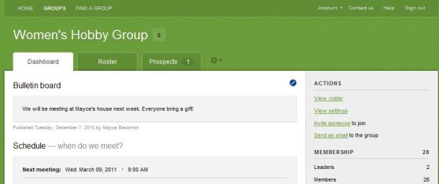
Your Group dashboard consists of the following:
- Schedule – when your Group meets (day, start time, end time)
- Location – where your Group meets (i.e. your home, Starbucks, etc.) and specific address. If your Group meets off-campus, we will keep the location hidden in the Group Finder, but it will be viewable to those who are members of your Group.
- Information/Details – Group name, description, marital status, gender, and age range
If you notice that any of this information is incorrect when you are viewing your Group Dashboard, contact Catherine at catherinewnewlifeeverett.org and send necessary updates.

GROUP FEATURES // ROSTER
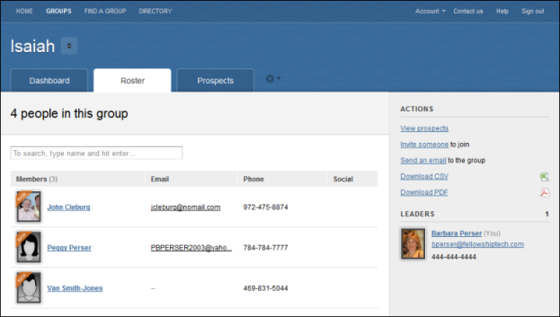
Your Group roster lists all of the members of your Group along with their email addresses, phone numbers, and social media information.

VIEW/EDIT MEMBER DETAILS
You will have the ability to view and/or edit member details including personal information. For example, if a Group member moves, you can update the individual’s record. Additionally, Group leaders can see the other Groups the individual is involved with.
To view/edit member details:
- From the Group roster, click on an individual’s name. You will be able to see their profile information, Group history, and past attendance.
  - On the individual’s profile tab, you have the ability to change the date that they joined your Group if they were added into InFellowship after they joined. By editing the date, attendance can be posted for the new member for their initial visit. Simply select Edit next to Member Since
- Click Edit this person in the Actions list on the right side of the page
- Add or change any necessary information
- Click Save changes
REMOVE AN INDIVIDUAL FROM YOUR GROUP
If a person no longer wants to be a member of your Group, you can remove the person from your roster.
To remove someone from you Group:
- Click on a person’s name in the roster to display the person's information
- Click Remove from Group in the Actions list on the right side of the page. A confirmation window will appear
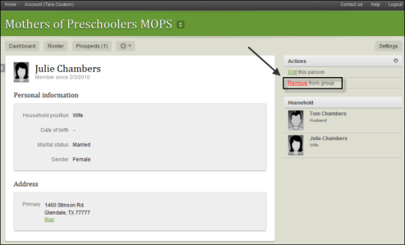
- Click OK to confirm removing the person from your Group

EMAILING YOUR GROUP
To send an email to your Group in InFellowship, follow these steps:
- Click Send an email under Actions
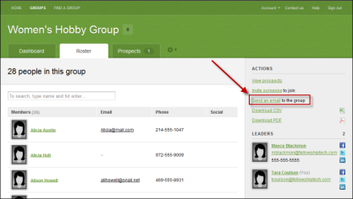
- Select Send an email to everyone in the Group or Let me choose which people to email
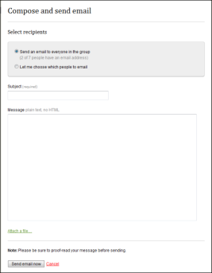

- Compose email
- Click Send email now
Note: Recipients can unsubscribe from emails from the InFellowship
application. If a Group member has unsubscribed, they will not receive your email. They do have the option to opt back in to email using their InFellowship account - Profile settings >Update your profile > Email > uncheck the Unsubscribe box.
GROUP FEATURES // ATTENDANCE
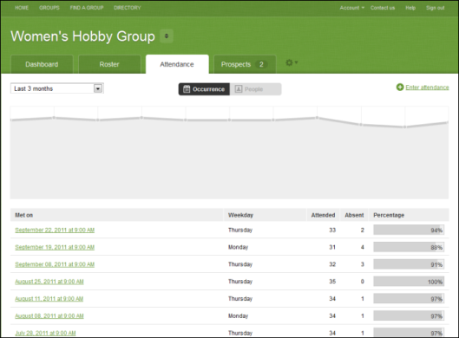
The chart in the example above gives you a glimpse of the attendance trends for the default time frame of the Last 3 months. You can use the drop-down list to select any of the other options. Other choices available are: last 6 months, last 9 months, and last 12 months.

The graph is interactive. You can hover over the peaks and valleys and see details regarding the Group attendance. Historical attendance is shown four ways in InFellowship:
- Occurrences over a date range
- Percentage breakdown for all members
- Past attendance for an individual
- Past attendance on a specific date
To see the attendance history regarding members of a specific Group, click the People option at the top of the page.
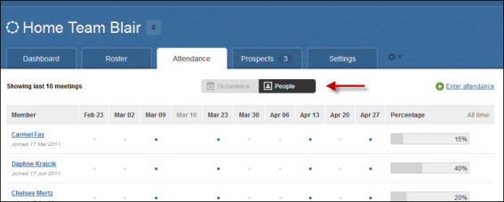
If you notice that a Group member has not been attending regularly, you can drill farther into the Group information by clicking on the individual's name.
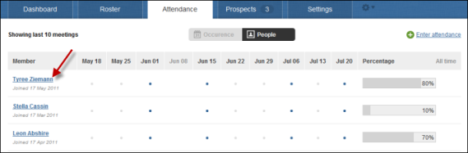
Here you can see personal information about the Group member along with preferred contact information. You can use this information to contact the individual to follow-up to see if they have transferred to another Group or need additional care.
POSTING ATTENDANCE
- Click the Attendance tab
- Click Enter Attendance to get started
- Select the date of the meeting from the drop down menu
- Choose either yes or no to answer the question regarding whether or not your Group met
- If your Group met, you can select all the Group members by clicking the box in the header bar of the roster or select members individually by clicking in the box next to a Group member's name.
Note: If a Group member’s name does not appear on the attendance list, but the person is on your roster, they were added to the Group after the time of the meeting. Because of this, the system will not allow you to record their attendance until you change their Member since date. You can do so by following the instructions on page 6 under the section, View/Edit Member Details
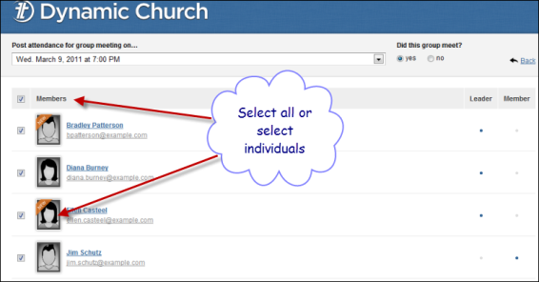
Make sure you click Save attendance at the bottom of the screen when you are finished.

If your Group did not meet, choose no and enter a note explaining why you didn't meet. Don't forget to click Save attendance.
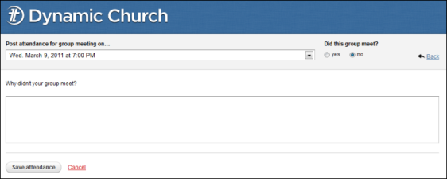
GROUP FEATURES // PROSPECTS
A prospect is an individual who has inquired about a Group via InFellowship. It is the primary responsibility of the Group leader to manage prospects.
How to interact with prospects:
- When a prospect has expressed interest in joining your Group by utilizing the Group Finder, you will receive an email with a link to sign in to InFellowship.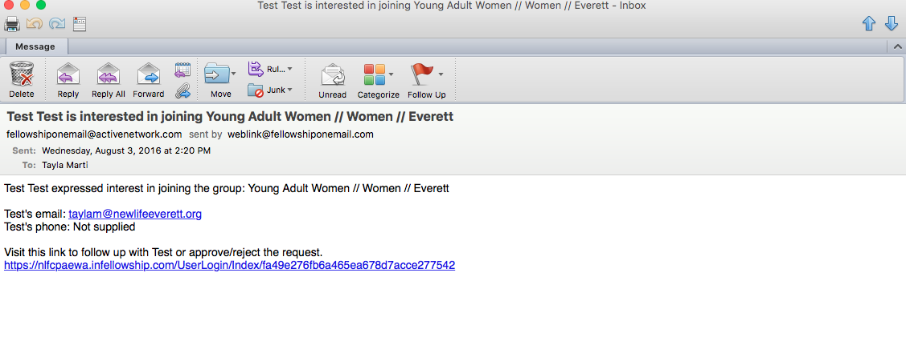
- Once you sign in, select the necessary Group
- Click on the Prospects tab
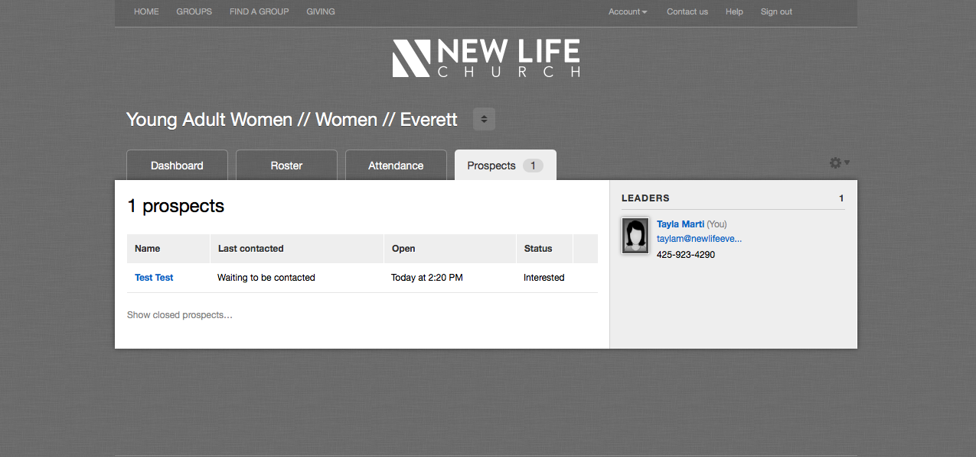
- Click on the name of the new prospect
- Click Send an email. A subject is automatically created, but feel free to edit it if you prefer. 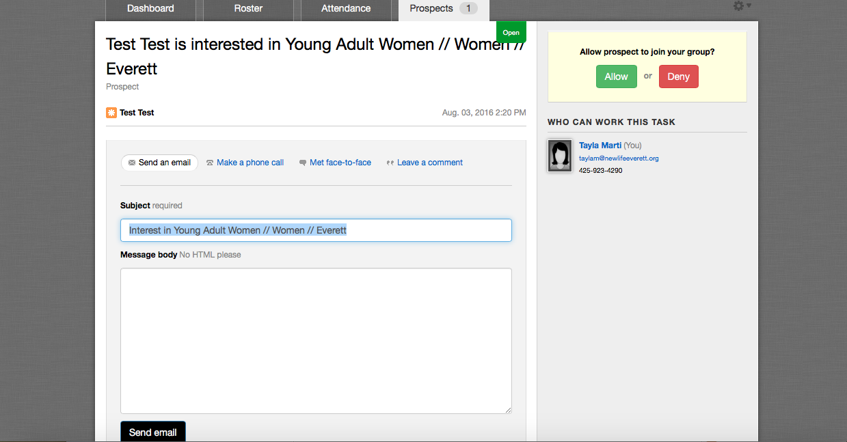
- Use this template in the Message body section and personalize as necessary:
Hi [First Name]! Thank you so much for expressing interest in my Group, [Group Name]. I would love to have you a part of it! You will be receiving a second email with a link to complete the sign-up process. Follow the link and select <JOIN THIS GROUP>. Log in with your New Life Account. If you do not have an account, you will be prompted to create one. Once logged in, you will be able to view Group details such as schedule, location, and a roster by clicking <YOUR GROUPS>. If you have any questions, please don't hesitate to ask! Our first meeting will be [day of the week, month, day, time, location]. I look forward to seeing you then! - Blessings, [Your First & Last Name]
- Click Send email
  - If you contact the prospect by any other means than email, make sure to make a note on your interaction. To record these notes, choose Make a phone call, Met face-to-face, or Leave a comment.
- On the right hand side you will see the option to Allow or Deny. Click Allow.
ADD SOMEONE TO YOUR GROUP
Once you’ve signed in to InFellowship and selected the necessary Group:
- In the Actions area, click Add someone to join
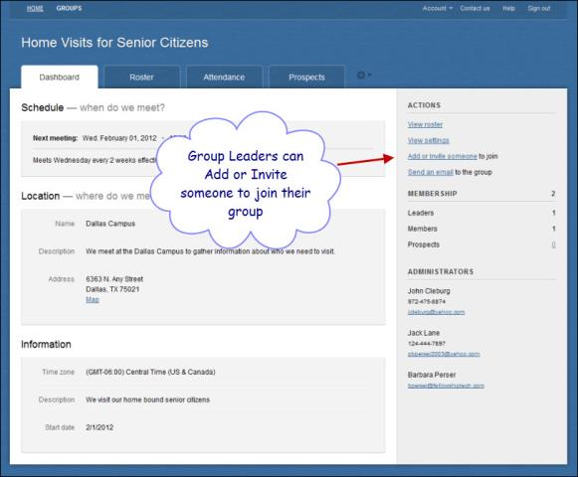

- Enter as much information as possible about the person you are adding.
Tip! Type in the full name of person you want to find. The system is looking for an exact match. For example, if you search for Jane Do, the system will not find Jane Doe.
- Click Next. InFellowship will try to match the individual to an existing record. All possible matches display
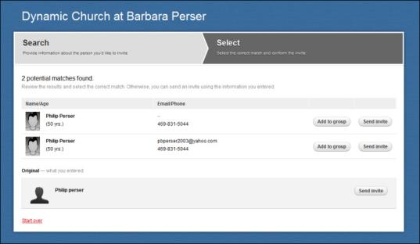
- Click Add to Group beside a matching record
- Confirm the Group addition by clicking Add to Group again
The individual will now appear in your Group roster. They will not receive an email notification, but will immediately be able to see the Group in their InFellowship account. Make sure to notify them that they now have access to the Group through InFellowship. See step 1 on page 8 under View/Edit Member Details if you need to adjust the date of when the individual actually joined your Group versus when they were added to InFellowship.

Important! When Group leaders add someone to the Group roster, they bypass any permissions and privacy settings that the member would normally give as to what information about them appears to the Group. When members join through an invitation, they are giving permission to be seen in the Group. They are also able to adjust their privacy settings. Since the Group leader is adding the new Group member, new members should be informed that they can adjust privacy settings to their liking.

NEED MORE HELP?
If you have questions about InFellowship:
Contact Catherine Weholt
catherinew@newlifeeverett.org

